**IOT_PHASE-5**

**PROJECT: ENVIRONMENTAL MONITORING**

**OBJECTIVE OF THE PROJECT:**

1. **Environmental Monitoring**: The primary objective is to monitor and collect real-time environmental data in a park setting. This includes temperature and humidity levels. This data can be valuable for various purposes, such as understanding the park's microclimate, tracking weather conditions, and assessing the comfort of park visitors.

2**. User Experience**: Enhancing the user experience in the park is a key goal. By providing real-time data on temperature and humidity, visitors can make more informed decisions about when to visit, what to wear, and how to prepare for their park experience. This contributes to increased visitor satisfaction.

3. **Safety and Comfort**: Real-time environmental data helps ensure the safety and comfort of park visitors. For instance, it can trigger alerts or notifications when extreme weather conditions are detected, allowing park management to take action, such as closing the park during adverse conditions.

4. **Data-Driven Decisions**: The project aims to provide park administrators with valuable data for making informed decisions. They can use historical data to plan maintenance activities, optimize energy usage, and enhance park infrastructure. Data can also be used to better manage resources, such as irrigation systems.

5**. Educational Value**: The project may have an educational component, as it can be used for research and educational purposes. It provides an opportunity for students, researchers, and the public to access and analyze environmental data from a real-world setting.

6. **Sustainability**: Monitoring environmental conditions can contribute to sustainable practices in the park. For instance, it can help with water conservation, as humidity data can inform decisions about when and how much to water park landscapes.

7. **Remote Access**: The real-time data accessible via a website provides remote access to the park's environmental conditions. This can be valuable for park administrators, visitors, and researchers who may not be on-site but still want to access the information.

8**. Demonstration of IoT Technology**: The project can serve as a practical demonstration of IoT technology and its applications in environmental monitoring. It showcases how IoT devices can be used to collect, transmit, and display data on the web.

9**. Public Engagement**: By making the data available through a website, the project can engage the public in park activities and environmental monitoring. Park visitors can check conditions before planning a visit, and the website can include educational content about the park's ecology.

**IoT Device Deployment:**

**Sensor Deployment:**

The device deployment section for park environment monitoring using IoT involves strategically situating various sensors to collect essential data. In this case, temperature sensors, humidity sensors, motion and presence sensors, and light sensors are deployed to provide comprehensive environmental insights.

1. Temperature Sensors: Temperature sensors are strategically placed at multiple locations throughout the park to capture variations in temperature. These sensors can be mounted on lampposts, trees, or dedicated sensor poles at different heights to record temperature differences closer to the ground and higher up in the air. By placing sensors in shaded areas, open spaces, and near water bodies, the system can capture a wide range of temperature data. This enables the monitoring of microclimate variations and helps in understanding temperature fluctuations within the park.

2. Humidity Sensors: Humidity sensors are also distributed across the park environment to monitor moisture levels in the air. These sensors are often positioned near ground level in areas with varying vegetation and near bodies of water. Measuring humidity at different locations aids in assessing the park's microclimate, as humidity can fluctuate considerably based on factors like proximity to water sources, vegetation density, and sunlight exposure.

3. Motion and Presence Sensors: Motion and presence sensors are strategically deployed at key points around the park to detect the movement of visitors and wildlife. These sensors are often placed near park entrances, trails, and popular viewing areas. When motion or the presence of individuals or animals is detected, the sensors trigger data recording and can capture the number of visitors or the presence of wildlife. This information helps in understanding peak visitation times and identifying areas with high wildlife activity, contributing to visitor safety and wildlife conservation efforts.

4. Light Sensors: Light sensors are positioned in various locations to monitor the park's lighting conditions. These sensors are crucial for understanding light intensity, especially in areas where visitors might require adequate illumination, such as parking lots, walkways, and recreational zones. Light sensors can also be installed near park facilities to assess indoor lighting and energy usage.

The deployment of these sensors is a critical step in creating a comprehensive IoT system for park environment monitoring. Careful consideration of sensor placement ensures that the system captures data from diverse park regions, including those with varying microclimates, visitor activity levels, and lighting requirements. The data collected from these sensors is transmitted in real-time to a central database or platform, where it is processed and made available for park administrators, researchers, and the public. This data enables data-driven decision-making, enhances visitor experiences, and supports environmental conservation and sustainability efforts within the park.

**PLATFORM DEVELOPMENT:**

We have developed a website that shows the real time data of the park environment to the park visitors (or any users).

* This website is designed to deliver real-time data and recommendations for park visitors. The webpage structure includes essential components such as navigation, informative content, and social media links.
* The webpage incorporates a responsive navigation menu that allows users to explore different sections of the website. Clicking the menu icon reveals the menu, and clicking the "x" icon hides it, making it suitable for mobile devices.
* The site's main content section highlights the features it offers, emphasizing the monitoring of crucial environmental parameters. These include temperature, humidity, infrared motion detection, and light-dependent resistor (LDR) sensors for efficient park lighting. These features aim to enhance the safety, comfort, and overall experience of park-goers.

**CODE IMPLEMENTATION:**

**WEBSITE**

* In the initial phase of the project, the website is developed using HTML and CSS. HTML (Hypertext Markup Language) is used to structure the web content, while CSS (Cascading Style Sheets) is employed for styling and layout. The website provides the user interface for accessing real-time environmental data from the IoT system deployed in the park.
* HTML (Hypertext Markup Language): HTML is used to define the structure and content of the website. It includes elements for creating navigation menus, content sections, forms for user interactions, and embedding images and maps. The HTML code is responsible for ensuring that the website's structure is organized and user-friendly.
* CSS (Cascading Style Sheets): CSS is utilized to style the website, including defining the layout, colors, fonts, and responsive design. It ensures that the website has an attractive and consistent appearance across various devices and screen sizes.

**IOT SYSTEM**

* IoT System Development (C Language in Wokwi):
* The core of the project involves implementing the IoT system responsible for monitoring the park environment and transmitting real-time data to the website. This IoT system is developed using the C programming language within the Wokwi platform. Here's how it works:
* C Language: The C programming language is used to write the code that runs on the IoT devices deployed in the park. This code includes instructions for reading data from the various sensors (temperature, humidity, motion, presence, and light), processing the data, and transmitting it to a central data repository. C is chosen for its efficiency and low-level hardware control capabilities, making it suitable for embedded systems like IoT devices.
* Wokwi Platform: Wokwi is an online platform for hardware and software development, particularly for Arduino-based projects and IoT devices. In the context of this project, Wokwi provides a virtual environment for testing and simulating the C code on microcontrollers and IoT hardware.

The combination of website development and IoT system implementation forms a cohesive solution where real-time environmental data collected by IoT devices is displayed to users through the website. The IoT devices, programmed in C, gather data from the park environment and securely transmit it to the website, enhancing the park's management and visitor experiences. This code implementation process results in a user-friendly web interface for accessing valuable environmental data, contributing to park sustainability and the well-being of visitors.

**SCREEN SHOTS OF IOT DEVICES:**

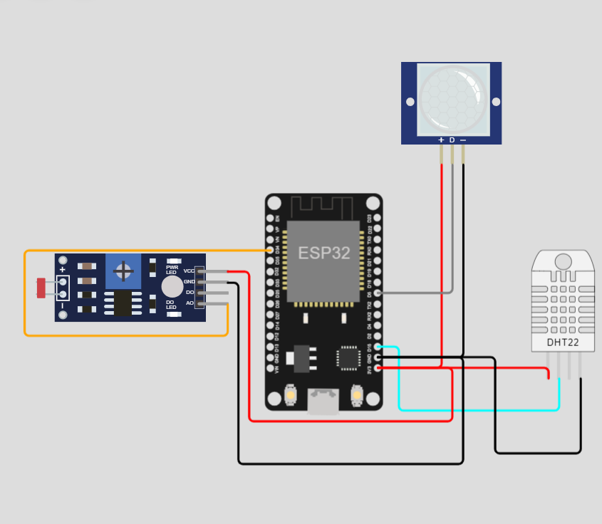

The above image depicts the presence of Temperature, Humidity and motion detection sensor with the ESP32 as the microprocessor.

**IOT SYSTEM CODE:**

**Library code:**

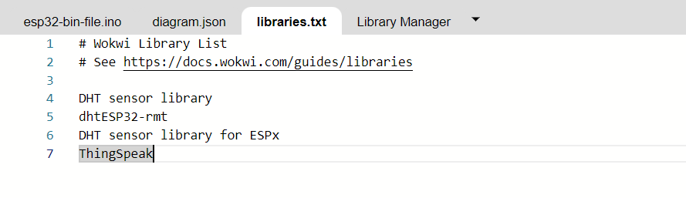

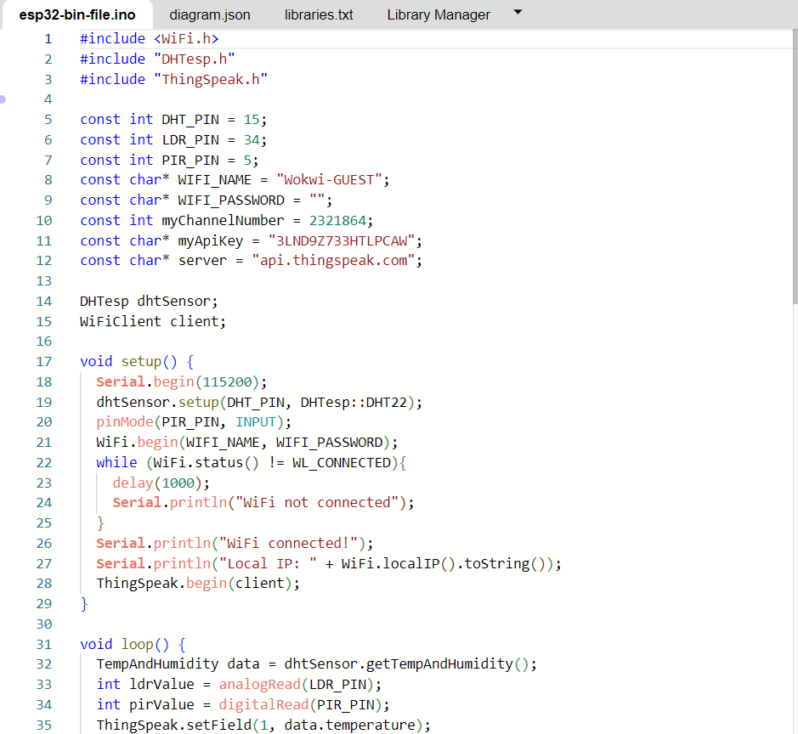

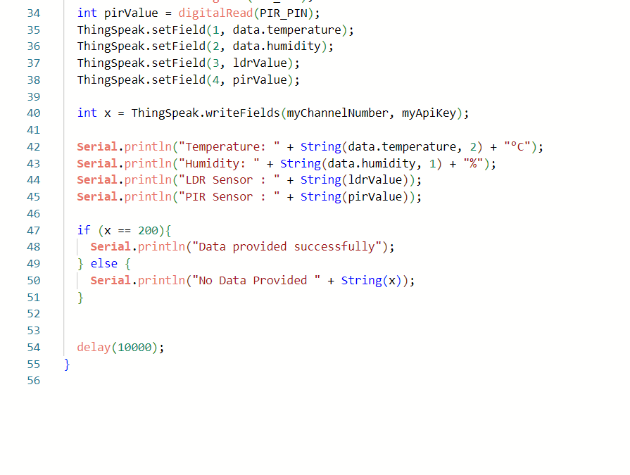

**Library manager:**

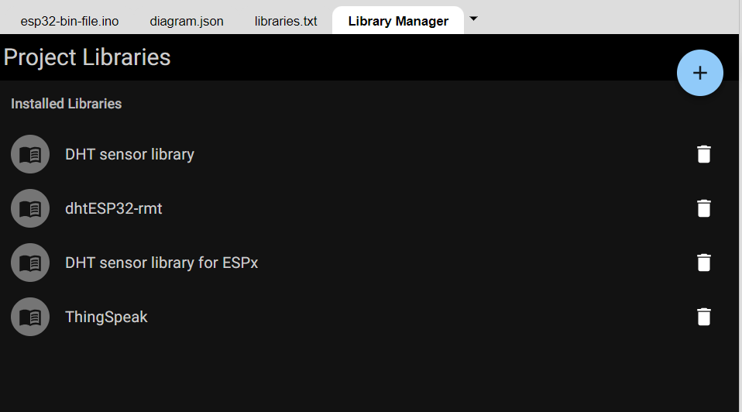

**ENVIRONMENTAL MONITORING PLATFORM AND DATA DISPLAY:**

**ENVIRONMENTAL MONITORING PLATFORM: WEBSITE**

**INDEX/HOME PAGE:**

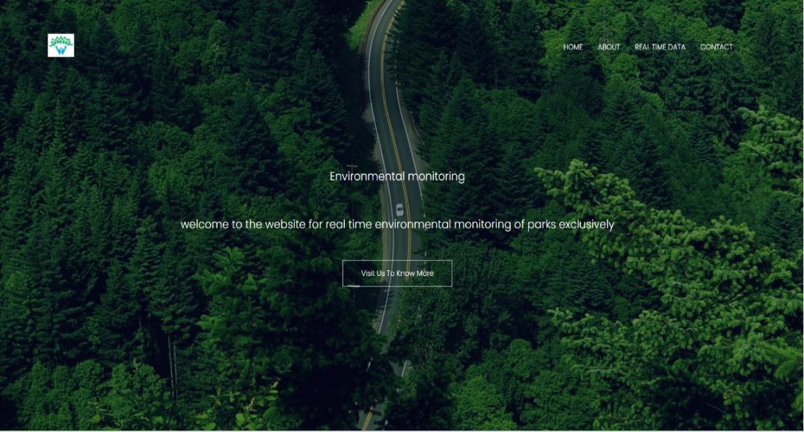

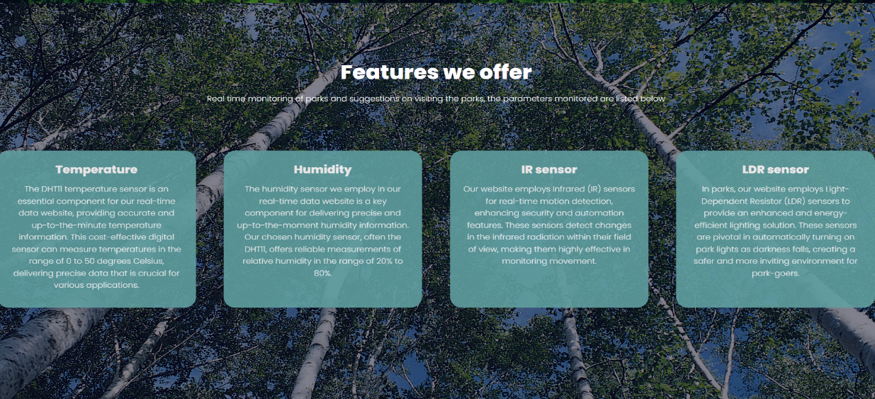



**ABOUT PAGE**

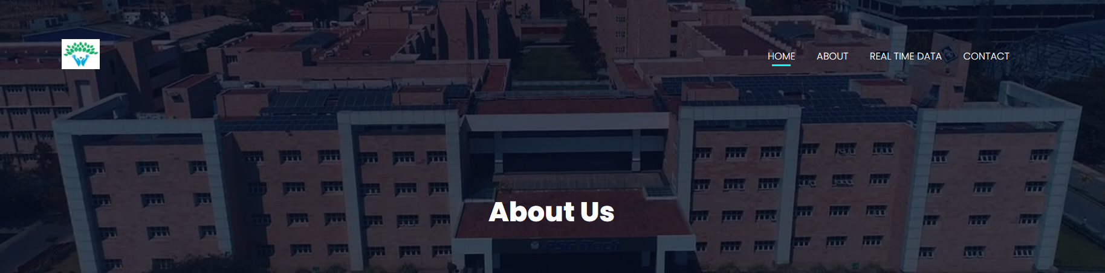



**REAL TIME DATA PAGE:**



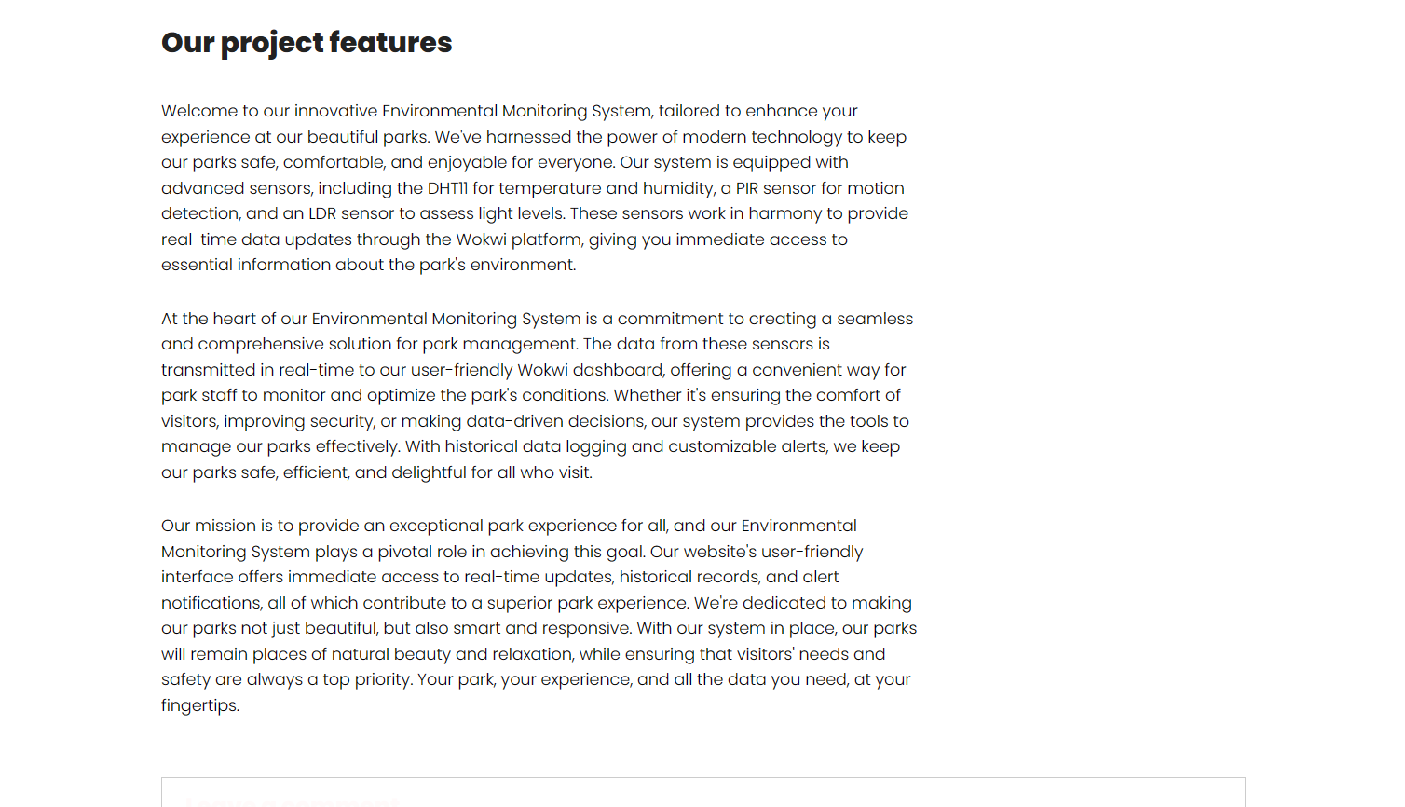



**CONTACT PAGE:**

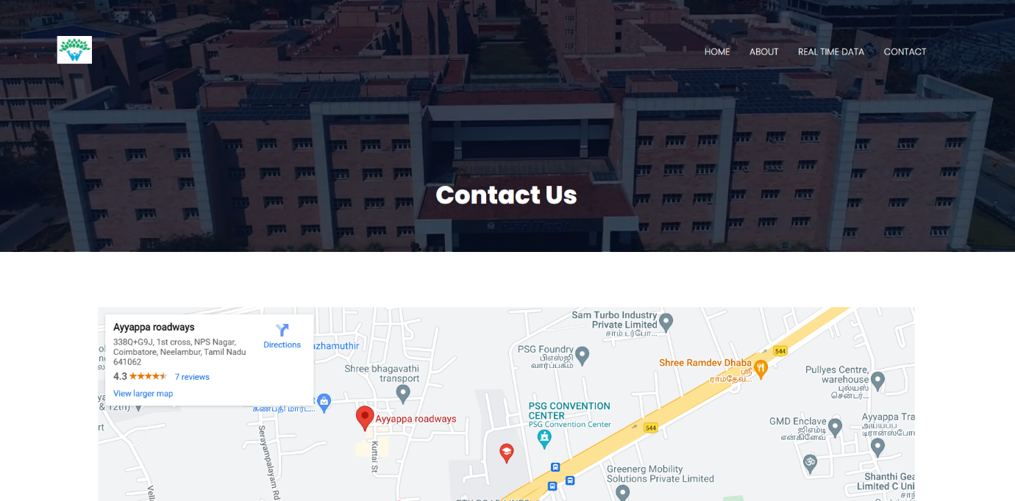

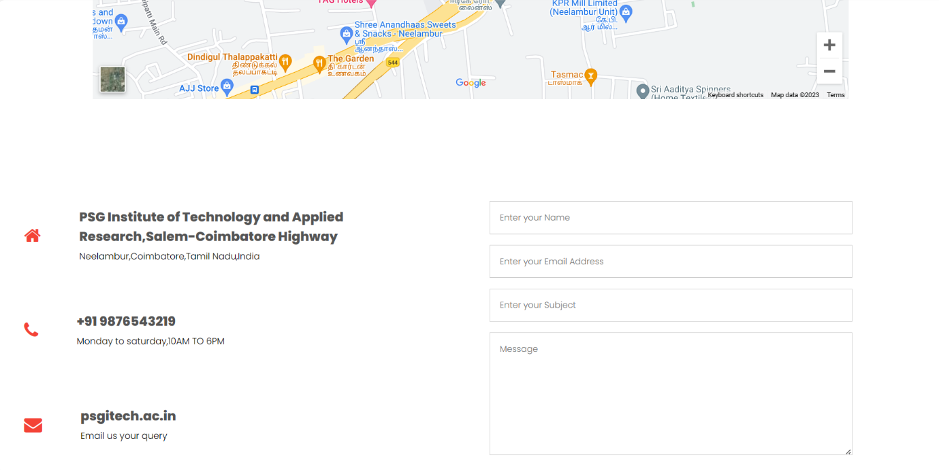



**DATA DISPLAY:**

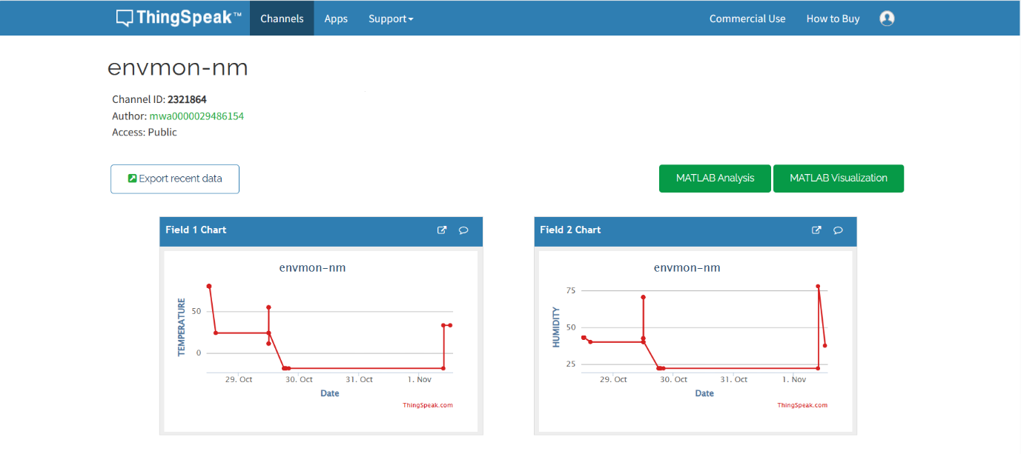

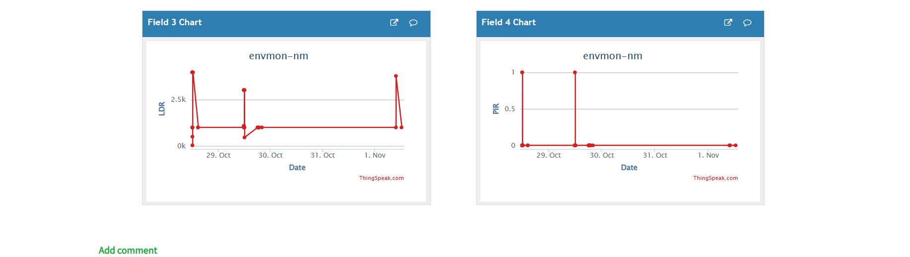

The graphs above depict the user (Park visitor) about the current environmental data of the park like the current temperature and humidity.

**Benefits for the park monitor from our website include:**

The real-time environmental monitoring system deployed in parks, which includes temperature and humidity sensors along with motion detection sensors, offers several key benefits to park visitors and promotes outdoor activities:

* **Enhanced Comfort and Safety**: The continuous monitoring of temperature and humidity levels ensures that park visitors are comfortable during their outdoor activities. They can plan their visits better, knowing the current weather conditions, which reduces the risk of discomfort due to extreme weather. The motion detection sensors also contribute to safety by alerting park authorities to any unusual activities or potential security concerns.
* Timely Information: Real-time data from temperature and humidity sensors allows visitors to make informed decisions about their outdoor activities. They can dress appropriately for the weather and plan outdoor events, picnics, or hikes accordingly. This information also helps in avoiding adverse weather conditions, enhancing safety and enjoyment.
* Optimized Resource Management: The data collected by the temperature and humidity sensors can be used to optimize resource allocation. For instance, irrigation systems can be activated based on the environmental conditions. This conserves resources, maintains the park's appeal, and ensures visitors have a pleasant experience.
* Energy Efficiency: The system may use the motion detection sensors to control lighting and other amenities, saving energy when no one is present. This not only reduces operating costs but also contributes to sustainability and a more natural outdoor environment.
* Data-Driven Decision-Making: Park authorities can make informed decisions based on the data collected by the sensors. For instance, if the system detects a high number of visitors during specific times, resources can be allocated more effectively. This also aids in efficient maintenance and security measures, enhancing the overall visitor experience.
* Interactive Engagement: Real-time data from temperature and humidity sensors can be made available to visitors through the website, allowing them to interact with the information. Visitors can check current conditions, view forecasts, and understand how temperature and humidity levels affect their outdoor experience. This interaction adds an educational component to their visit.
* Promotion of Health and Well-Being: Encouraging outdoor activities aligns with a healthy lifestyle. Access to real-time data, especially temperature and humidity levels, encourages people to step outside for activities like walking, jogging, and picnicking, which promotes physical and mental well-being.